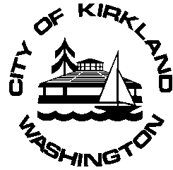 | Kirkland Senior Council Meeting
 | Date: March 12th, 2019
 | Time: 1:30 p.m.
 | Place: Sun Room, Peter Kirk Community Center

Our mission is to maintain and improve the quality of life for Kirkland seniors (age 50 plus) by identifying their concerns, advocating for their needs and by creating programs that advance their well-being while recognizing the value and contributions that seniors bring to our community.

AGENDA
Estimated Time
1. CALL TO ORDER

2. ROLL CALL 5 minutes

3. APPROVAL OF MINUTES 5 minutes
a. February 19th Meeting, 2019

4. UNFINISHED BUSINESS
a. 2019 Work Plan Programs Priority Review 20 minutes

5. Committee Chair Reports 25 minutes
a. Council Member Reports on Work Plan Programs

6. NEW BUSINESS
a.

7. COMMUNICATIONS 30 minutes
a. Staff Report and Updates
b. Member Reports

8. ITEMS FROM THE AUDIENCE 5 minutes

9. ADJOURNMENT Estimated meeting completion: 3:00pm

PARKING LOT DISCUSSIONS & SUB COMMITTEE MEETING(S)

Upcoming Senior Council Activities:

April 9, 2019 – Regular Kirkland Senior Council Meeting
May 14, 2019– Regular Kirkland Senior Council Meeting

