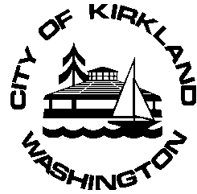 | Kirkland Senior Council Meeting
 | Date: February 19, 2019
 | Time: 5:30 p.m.
 | Place: Sun Room, Peter Kirk Community Center

Our mission is to maintain and improve the quality of life for Kirkland seniors (age 50 plus) by identifying their concerns, advocating for their needs and by creating programs that advance their well-being while recognizing the value and contributions that seniors bring to our community.

AGENDA
Estimated Time
1. CALL TO ORDER

2. ROLL CALL

3. APPROVAL OF MINUTES 5 minutes
a. January 8, 2019

4. ITEMS FROM THE AUDIENCE 5 minutes

5. UNFINISHED BUSINESS
a. Affirmation of 2019 Officers 5 minutes
b. Review Human Services Plan for KSC Support & Staff Function 15 minutes
c. Finalize 2019 Work Plan 40 minutes
d. Robert’s Simplified Rules of Order for the Kirkland Senior Council 5 minutes

7. COMMUNICATIONS 15 minutes
a. Member Reports
b. Staff Reports and Announcements

8. ADJOURNMENT Estimated meeting completion: 7:00pm

Upcoming Senior Council Activities:
March 12, 2019 – Regular Kirkland Senior Council Meeting
April 9, 2019 – Regular Kirkland Senior Council Meeting

